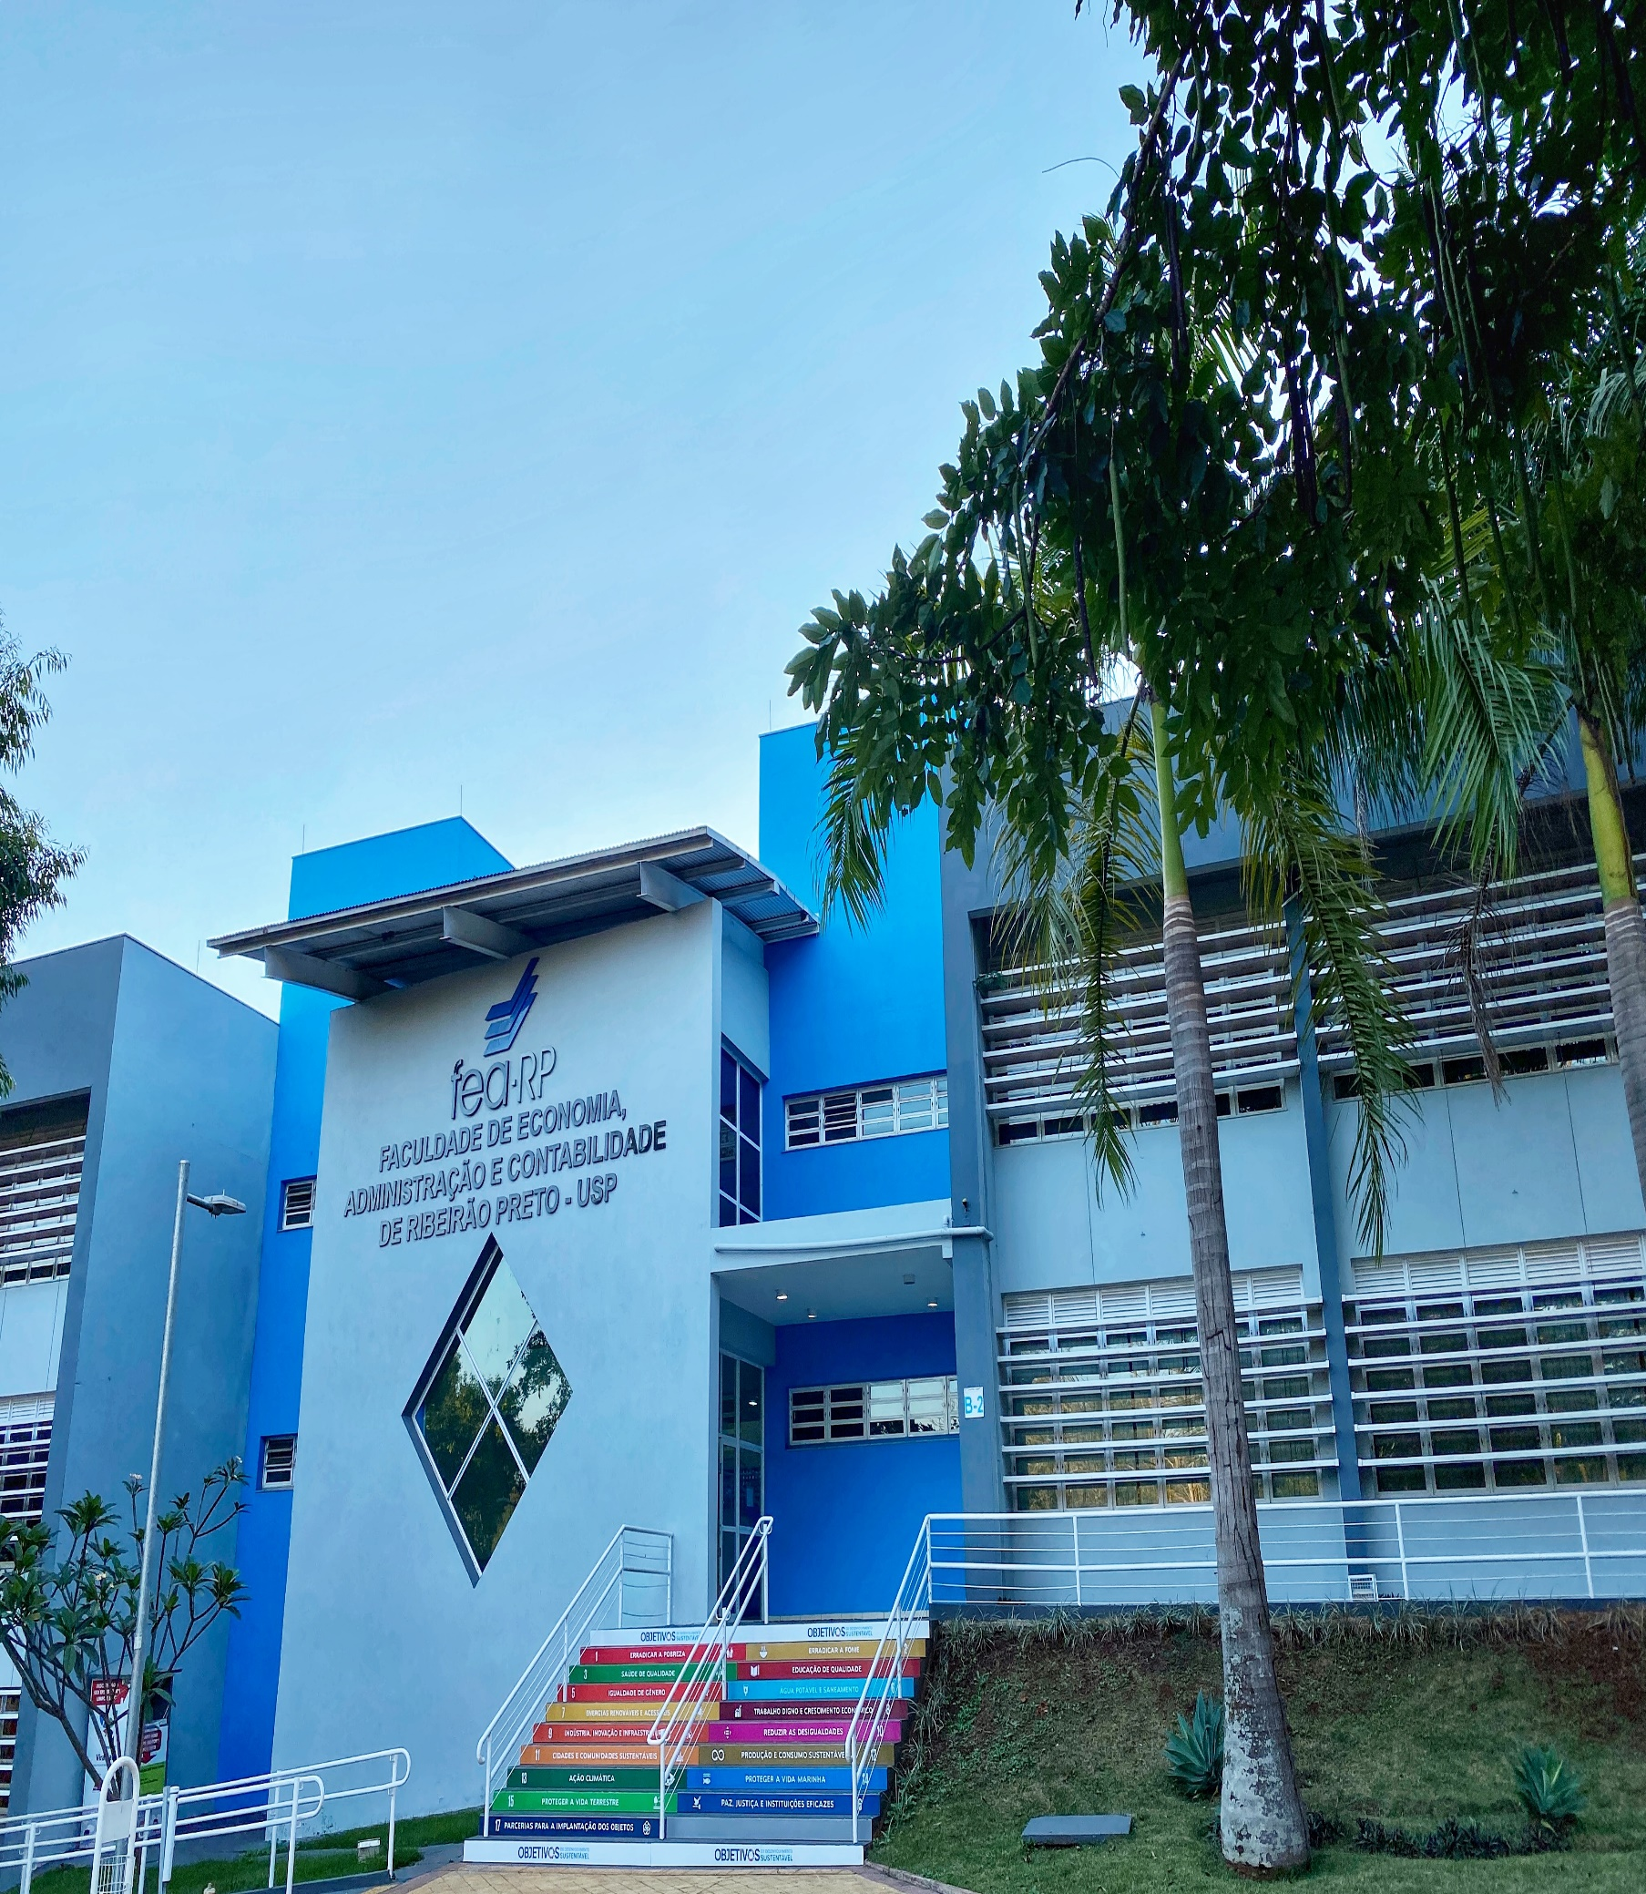
CERTIFICATE OF ENGLISH LEVEL

STUDENT INFORMATION

First name/middle/surname:

ACADEMIC INFORMATION

I certify that my student:
☐ Has the equivalent of a B1 level (CEFR) or higher in English.
☐ Is a native English speaker.

HOME INSTITUTION

Name
Stamp & Signature
Date:

